

DATABASE MANAGEMENT SYSTEM(CBS-1007)

SLOT: L33+34

LAB ASSESSMENT -2

NAME- GAURAV SINGH

REG NO.- 19BBS0026

**Q1 -Query:** Create table Product(marker varchar(10),model int PRIMARY KEY, type varchar(20));

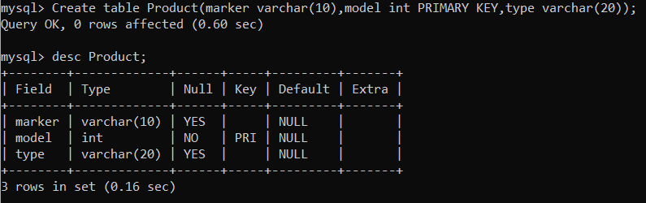

**Query:** Create table Laptop(code int PRIMARY KEY, model int, speed float,ram int,hd int,screen float, price int, foreign key(model) references Product(model))

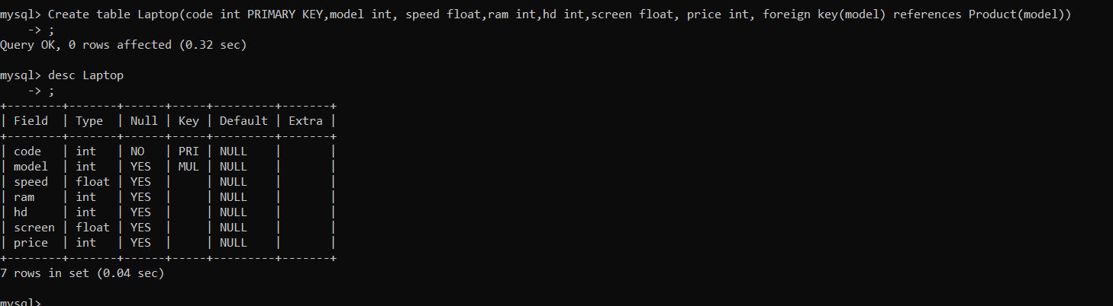

**Query:** Create table PC(code int PRIMARY KEY, model int,speed float,ram int,hd int,cd int, price int,foreign key(model) references Product(model));

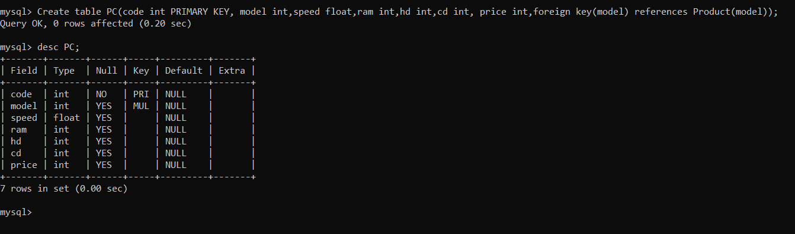

**Query:** Create table Printer(code int PRIMARY KEY, model int, ,color varchar(10),type varchar(20), price int, foreign key(model) references Product(model))

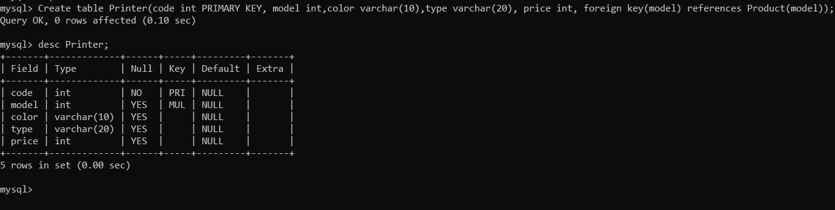

**Query:** INSERT INTO Product VALUES (‘L’, 5101, 'pc');

INSERT INTO Product VALUES ('L', 5102, 'pc');

INSERT INTO Product VALUES ('L', 5103, 'pc');

INSERT INTO Product VALUES ('M', 5104, 'pc');

INSERT INTO Product VALUES ('M', 5105, 'pc');

INSERT INTO Product VALUES ('M', 5106, 'pc');

INSERT INTO Product VALUES ('Q', 5107, 'pc');

INSERT INTO Product VALUES ('Q', 5108, 'pc');

INSERT INTO Product VALUES ('O',5 109, 'pc');

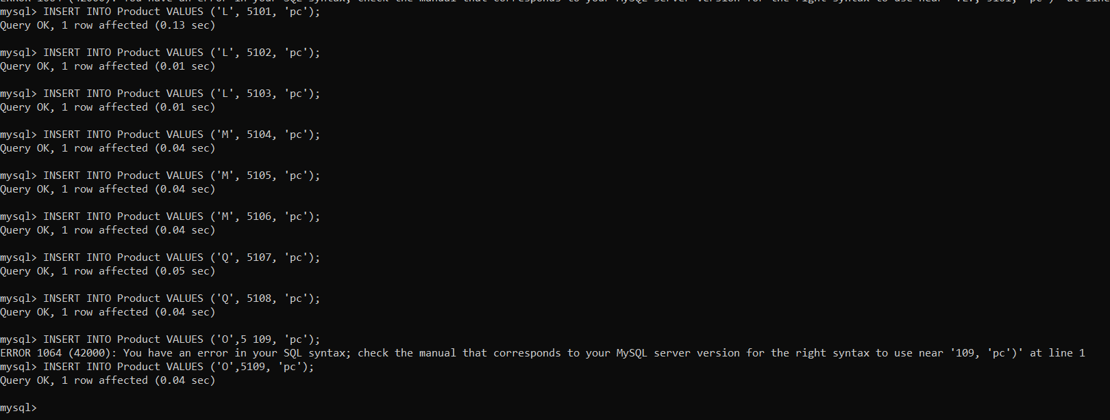

**Query:** INSERT INTO Product VALUES ('O', 6101, 'laptop');

INSERT INTO Product VALUES ('0', 6102, 'laptop');

INSERT INTO Product VALUES ('Q', 6103, 'laptop');

INSERT INTO Product VALUES ('Q', 6204, 'laptop');

INSERT INTO Product VALUES ('N', 6205, 'laptop');

INSERT INTO Product VALUES ('N', 6206, 'laptop');

INSERT INTO Product VALUES ('L', 6107, 'laptop');

INSERT INTO Product VALUES ('L', 6108, 'laptop');

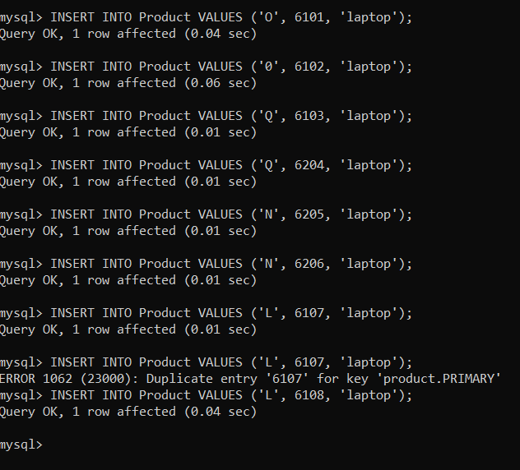

**Query:** INSERT INTO Product VALUES ('P', 7101, 'printer');

INSERT INTO Product VALUES ('P', 7102, 'printer');

INSERT INTO Product VALUES ('M', 7103, 'printer');

INSERT INTO Product VALUES ('M', 7104, 'printer');

INSERT INTO Product VALUES ('N', 7105, 'printer');

INSERT INTO Product VALUES ('N', 7106, 'printer');

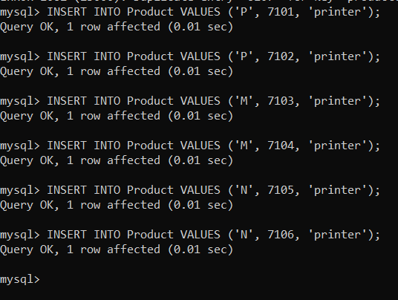

**Query:** Select * from Product;

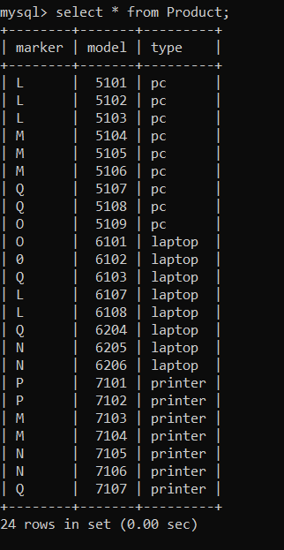

**For Pc**

**Query**(code, model, speed, ram, hd, cd, price)-

INSERT INTO PC VALUES (1001, 5101,2.36, 512,60, 80, 650);

INSERT INTO PC VALUES (1002, 5102, 1.20, 2048, 120,80, 770);

INSERT INTO PC VALUES (1003, 5103,4.42, 2048, 240,250, 478);

INSERT INTO PC VALUES (1004, 5104, 3.20, 512, 80,320, 1049);

INSERT INTO PC VALUES (1005, 5105,2.20, 2048, 250,320, 490);

INSERT INTO PC VALUES (1006, 5106, 2.00, 512, 320,80, 550);

INSERT INTO PC VALUES (1007, 5107, 3.20, 512, 200,250, 630);

INSERT INTO PC VALUES (1008, 5108, 3.40, 1024,120, 320, 770);

INSERT INTO PC VALUES (1009, 5109,1.25, 512,100, 200, 2114);

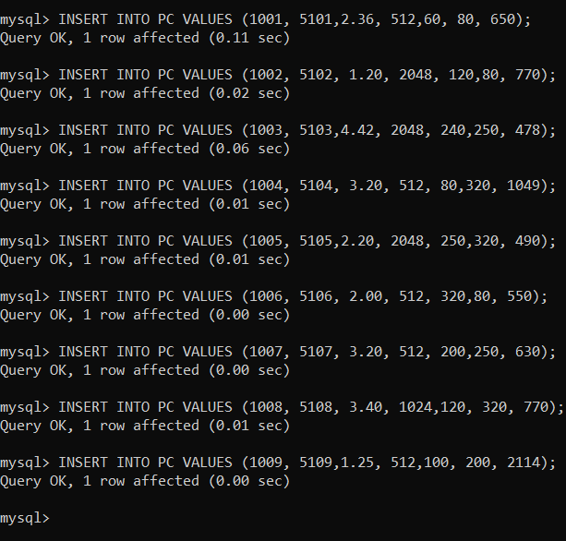

**Query:** Select * from PC

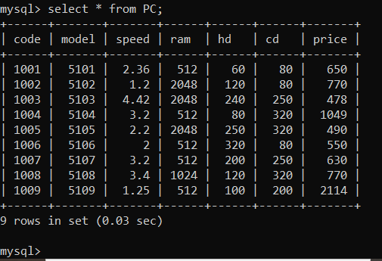

**for Laptop**

**Query:** Laptop(code, model, speed, ram, hd, screen, price)-

INSERT INTO Laptop VALUES (2001, 6101, 1.60, 512, 60,17.1, 949);

INSERT INTO Laptop VALUES (2002, 6102, 1.83, 2048, 240, 15.0, 3749);

INSERT INTO Laptop VALUES (2003, 6103,2.00, 1024, 80, 13.4, 1150);

INSERT INTO Laptop VALUES (2004, 6104, 1.92, 1024, 80, 17.3, 2250);

INSERT INTO Laptop VALUES (2005, 6105, 2.00, 2048, 240, 15.0, 1700);

INSERT INTO Laptop VALUES (2006, 6106, 2.16, 512, 120, 13.4, 1429);

INSERT INTO Laptop VALUES (2007, 6107, 1.78, 2048, 100, 17.1, 900);

INSERT INTO Laptop VALUES (2008, 6108,1.45, 2048, 120, 15.4, 949);

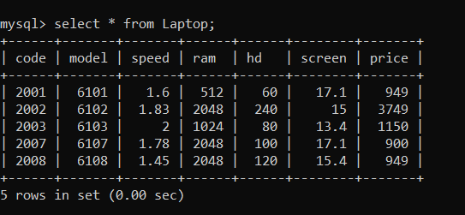

**Query:** INSERT INTO Printer VALUES (3001, 7101, ‘false’, ‘laser’, 139);

INSERT INTO Printer VALUES (3002, 7102,'false', ‘ink-jet’, 899);

INSERT INTO Printer VALUES (3003, 7103,'true', 'laser', 139);

INSERT INTO Printer VALUES (3004, 7104,'true', 'ink-jet', 99);

INSERT INTO Printer VALUES (3005, 7105,’true’, 'laser', 120);

INSERT INTO Printer VALUES (3006, 7106,’false’, 'ink-jet', 100);

INSERT INTO Printer VALUES (3007, 7107, 'true', 'laser', 99);

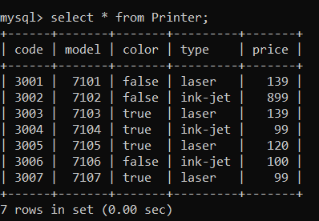

**1.** Find the model number, speed and hard drive capacity for all the PCs with prices below $500. Result set: model, speed, hd.

**Query:** select price,model,speed,hd from PC where price<500 group by model,speed,hd;

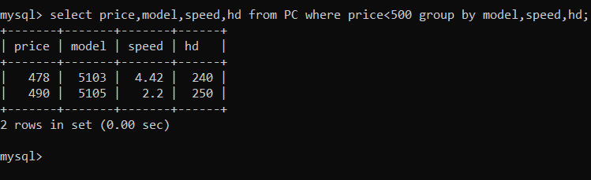

**2.** Find printer makers. Result set: maker

**Query**: Select distinct maker from Product where model in (select model from Printer);

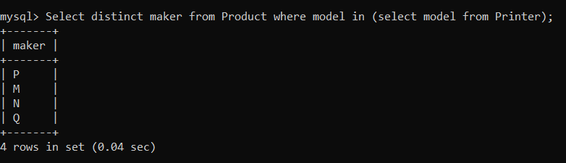

**3**.Find the model number, RAM and screen size of the laptops with prices over $1000

**Query:** Select model,ram,screen,price from Laptop where price > 1000;

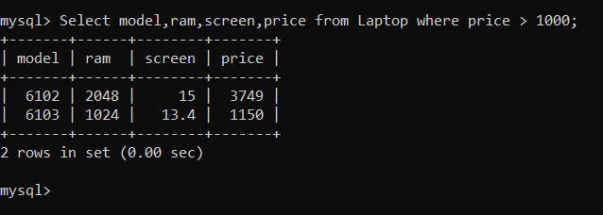

**4**.Find the model number, speed and hard drive capacity of the PCs having 12x CD ands prices less than $600 or having 24x CD and prices less than $600.

**Query:** Select model,speed,hd from PC where PC.cd IN (12,24) and price<600;

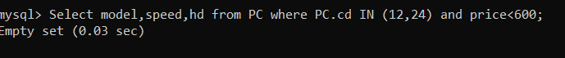

**5.** For each maker producing laptops with a hard drive capacity of 10 Gb or higher, find the speed of such laptops. Result set: maker, speed.

**Query:** Select distinct maker,speed from Product,Laptop where Laptop.hd>=10 and type in (select type from Product where type=’laptop’);

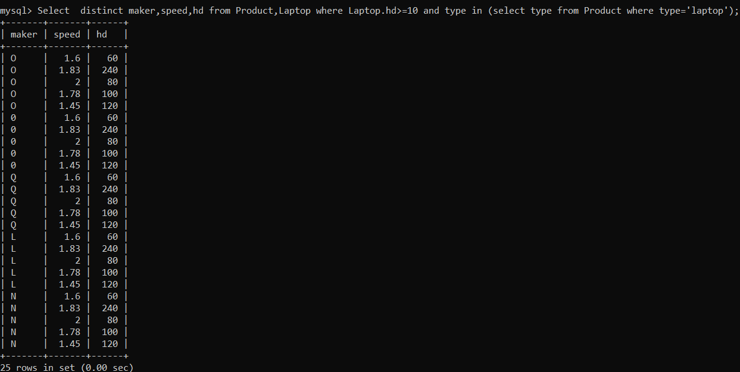

**6.** Find out the models and prices for all the products (of any type) produced by maker B.

**Query**: Select model,price from PC where model in (Select model from Product where maker =’M’ and type=’pc’) union select model,price from Laptop where model in (select model from Product where maker=’M’ and type=’laptop’) union select model,price from printer where model in (select model from Product where maker=’M’ and type=’printer’);

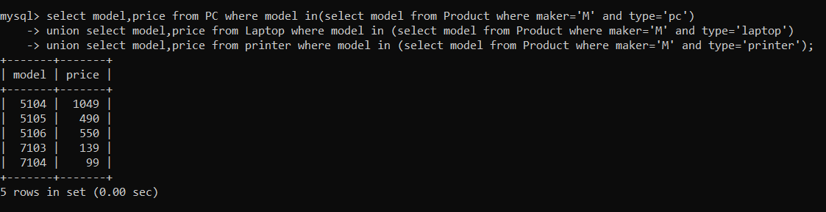

**7**. Find out the makers that sale PCs but not laptops.

**Query:** select distinct maker from Product where type ='pc' and not (type='laptop');

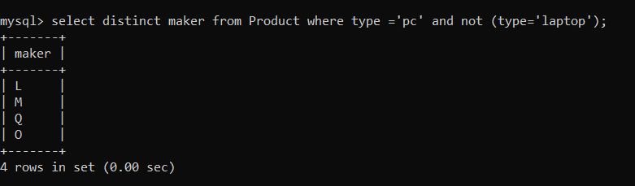

**8.** Find the printers having the highest price. Result set: model, price.

**Query**: Select model,max(price) from Printer;

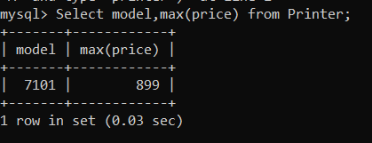

**9**. Find all the makers who have all their models of PC type in the PC table

**Query**: Select distinct maker from Product where model in (select model from Product where type=’pc’);

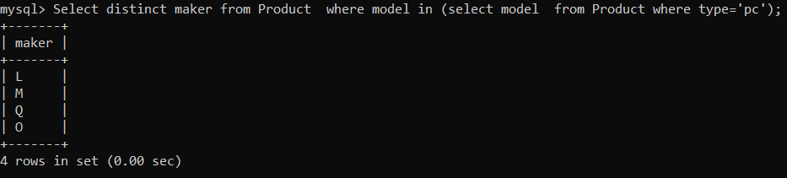

**10.** Find out the average speed of the PCs produced by maker A.

**Query:**Select model,avg(speed) from PC where model in (select model from Product where maker=’L’ and type=’pc’);

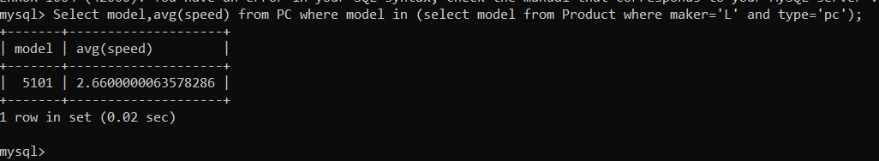

**Q2-**

**Query-** create table books(isbn int, title varchar(50), price float,qty int);

desc books;

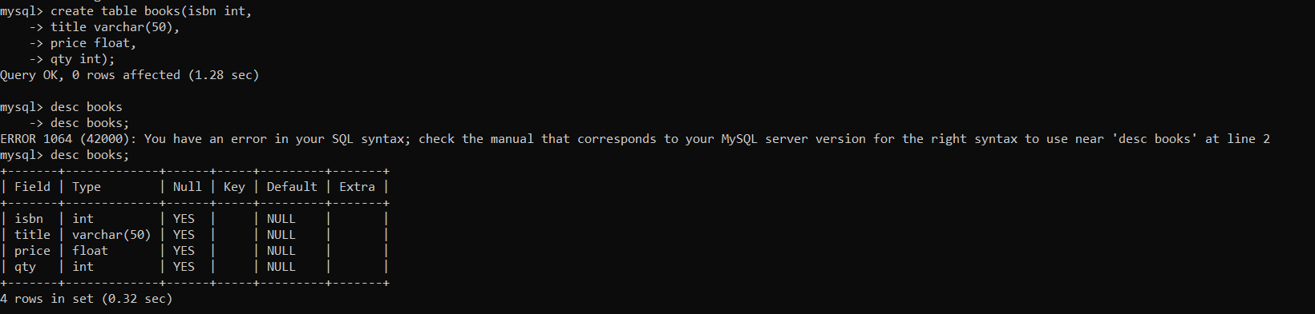

**Query-** create table books_authors( authorid int, isbn int);

desc books_authors;

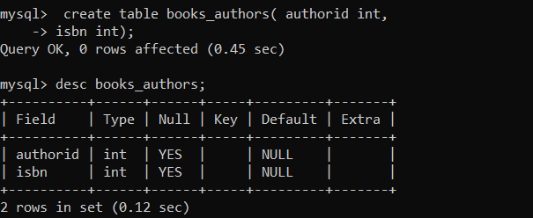

**Query-** create table authors( authorid int,name varchar(30),email varchar(50));

desc authors;

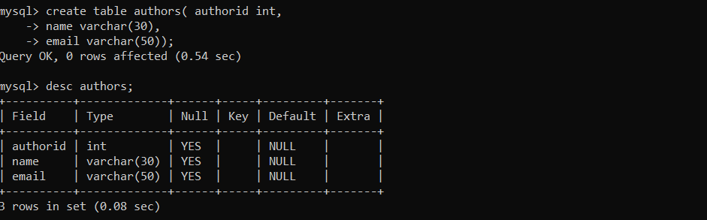

**Query:** INSERT INTO books VALUES(1000,'JAVA',15.21,2);

INSERT INTO books VALUES(1005,'PYTHON',22.21,2);

INSERT INTO books VALUES(1234,'CPP',19.21,5);

INSERT INTO books VALUES(1034,'C',22.21,2);

INSERT INTO books VALUES(1022,'HTML',15.31,7);

INSERT INTO books VALUES(1003,'CSS',34.21,5);

select *from books;

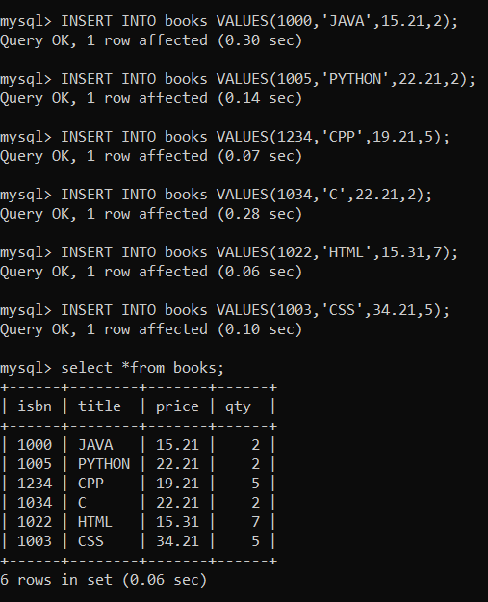

**Query:**

INSERT INTO books_authors VALUES(11,1000);

INSERT INTO books_authors VALUES(21,1005);

INSERT INTO books_authors VALUES(15,1234);

INSERT INTO books_authors VALUES(25,1034);

INSERT INTO books_authors VALUES(19,1022);

INSERT INTO books_authors VALUES(30,1003);

select *from books_authors;

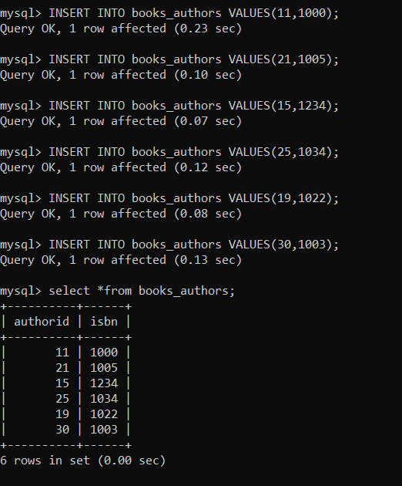

**Query:**

INSERT INTO authors VALUES(11,'GAURAV','xyx@gmail.com');

INSERT INTO authors VALUES(21,'SAURABH','xwx@gmail.com');

INSERT INTO authors VALUES(15,'KARAN','xax@gmail.com');

INSERT INTO authors VALUES(25,'UTSAV','xvx@gmail.com');

INSERT INTO authors VALUES(19,'VISHAL','xfyx@gmail.com');

INSERT INTO authors VALUES(30,'DAKSH','qyx@gmail.com');

select *from authors;

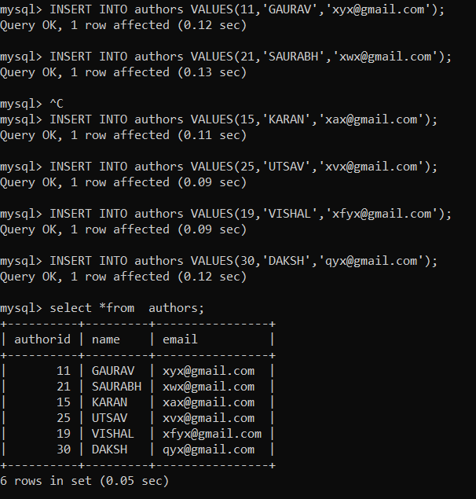

**1-**Add unique constraint to title in books table

**Query-** ALTER TABLE books ADD UNIQUE(isbn);

desc books;

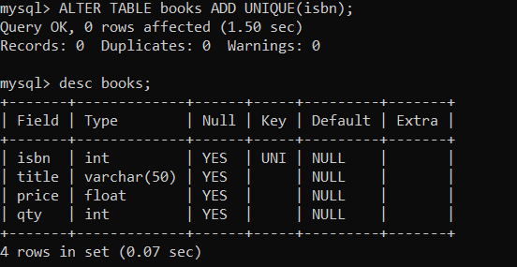

**2-** Add not null constraint to price in books table

**Query:** alter table books modify price float not null;

desc books;

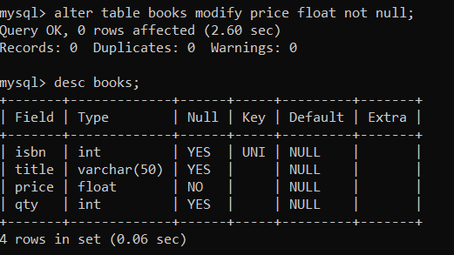

**3-** Alter check constraint in price that it greater than 0

**Query:** alter table books add check(price>0);

desc books;

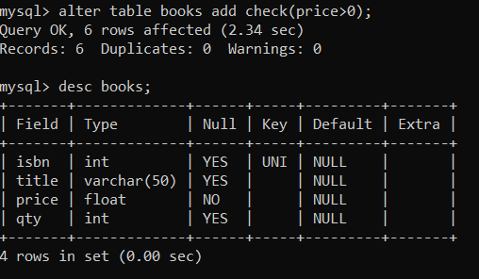

**4**- Drop not null constraints for qty

**Query:** alter table books modify qty int null;

desc books;

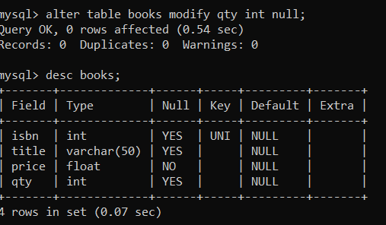

**5-** Set default qty for books to 0

**Query:** alter table books alter qty set default 0;

desc books;

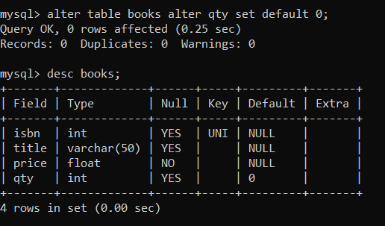

**6**-Dropemail from author table

**Query:** alter table authors drop column email;

desc authors;

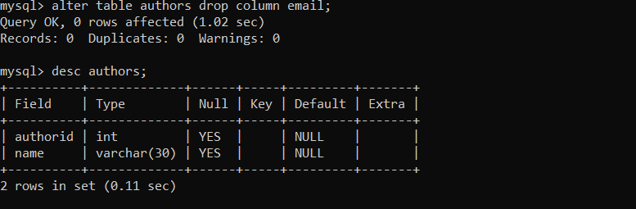

**7-** Dropany one foreign key constraint

**Query:**

alter table books_authors drop foreign key books_authors_ibfk_1;

desc book_aurthor;

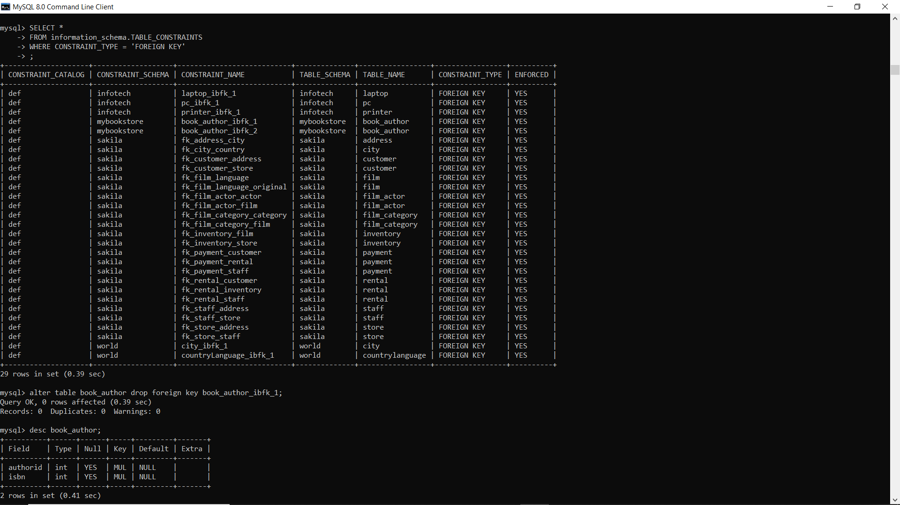

**8-** Drop a primary key

**Query:**

alter table author drop primary key; desc author; alter table authors drop column authorid;

desc authors;

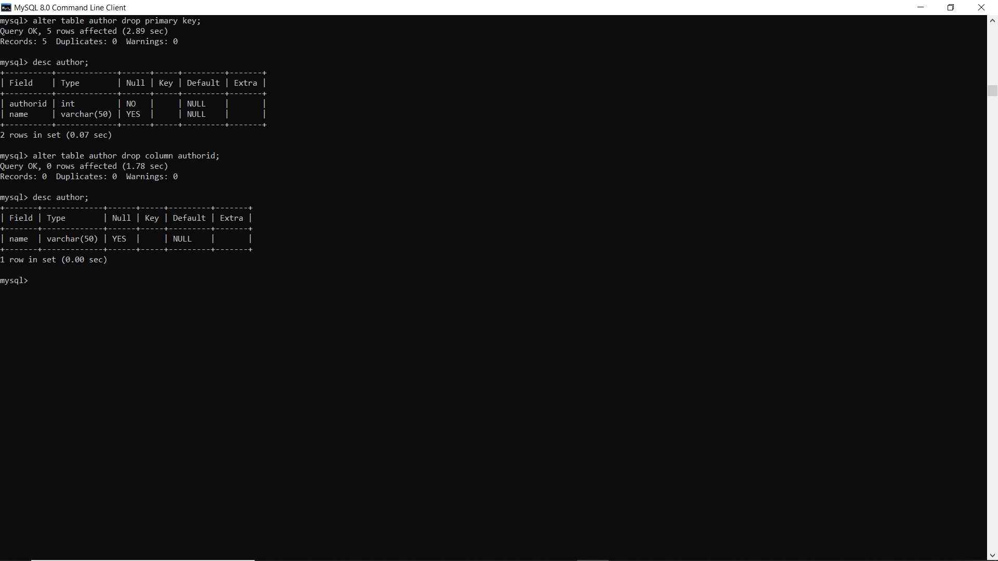

**9-** Attribute*to author table and set constraint for it*

**Query:**

alter table authors add authorSSN varchar(50);

desc authors;

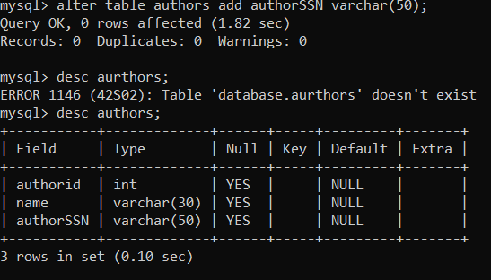

update authors set authorSSN='19BBS0026' where name='GAURAV';

update authors set authorSSN='19BCI0026' where name='SAURABH';

update authors set authorSSN='19BMI0026' where name='KARAN';

update authors set authorSSN='19BLI0026' where name='DAKSH';

update authors set authorSSN='19BBD0026' where name='VISHAL';

update authors set authorSSN='19BVS0026' where name='UTSAV';

alter table authors add primary key(authorSSN);

select* from authors;

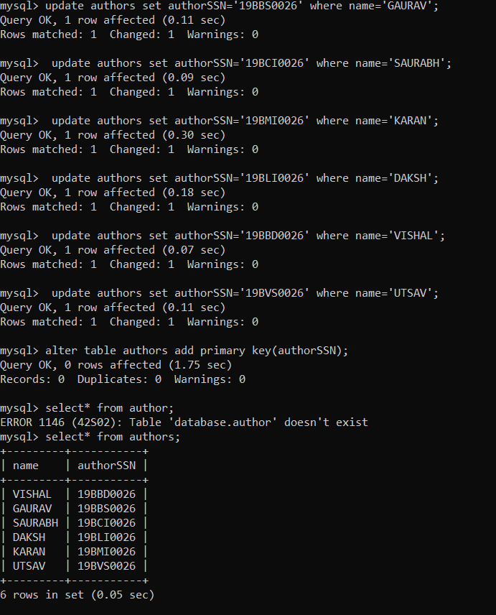

**Q 3:**

**Query:**

Create table department(deptNo int,deptName varchar(20), locationvarchar(20),constraint pk_dept primary key(deptNo));



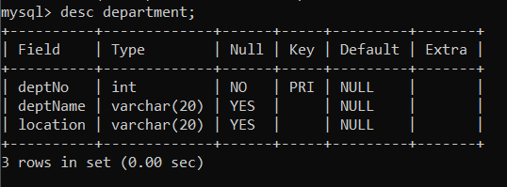

**Query:**

Create table employee(empNo int,empName varchar(20),job varchar(20),mgr int,hireDate date,salary int,comm int, deptNo int,constraint pk_emp primary key(empNo) ,constraint fk_deptNo foreign key (deptNo) references department (deptNo));

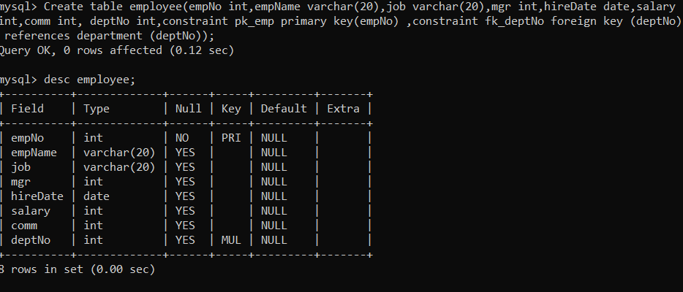

**Query:**

insert into department values(1001,”Frontend Developer”,”Hyderabad”);

Insert into department values(1002,”Backend Developer”,”Bangalore”);

Insert into department values(1003,”MERN stack developer”,”Mumbai”);

Insert into department values(1004,”MEAN stack developer“,”Lucknow”);

Insert into department values(1005,”UI Designer”,”Bhopal”);

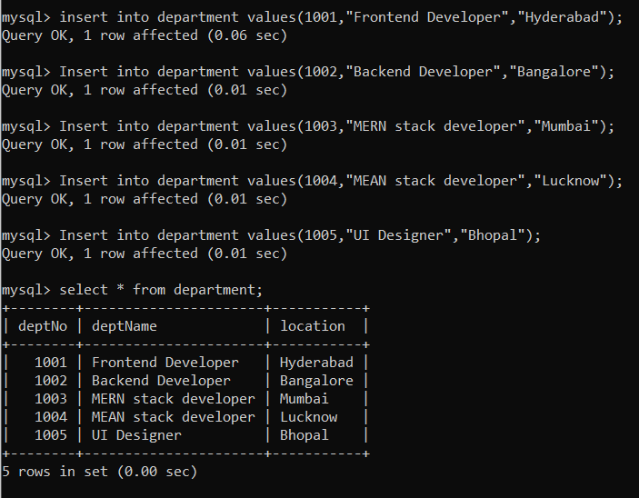

Manager-7121, team leader-4153,team member-8451,head manager-9999,presentator-1000,salesman-2000,president-1111,PA-8125

Query: insert into employee values(2001,”Shree”,”manager”,7121,”2017-05-1”,20000,4555,1001);

insert into employee values(2002,”Rohan”,”Team Leader”,4153,”2018-06-2”,30000,8421,1003);

insert into employee values(2003,”Satya”,”Head Manager”,9999,”2010-07-17”,45000,2785,1004);

insert into employee values(2004,”Vidya”,”Presentator”,1000,”2015-07-20”,11000,3245,1005);

insert into employee values(2005,”Ganesh”,”Team member”,4153,”2014-01-10”,28000,8571,1003);

insert into employee values(2006,”Rohit”,”Team Leader”,7121,”2017-05-1”,20000,4555,1001);

insert into employee values(2007,”nikhil”,”salesman”,2000,”2001-06-12”,8000,7514,1005);

insert into employee values(2008,”Shiva”,”Team member”,8451,”2014-06-1”,14000,5841,1002);

insert into employee values(2009,”Arjun”,”PA”,8125,”2015-01-1”,40000,1245,1001);

insert into employee values(2010,”Jagan”,”President”,1111,”2001-01-7”,84500,1279,1003);

**1.** Display the dept information from department table

**Query:**

select * from department;

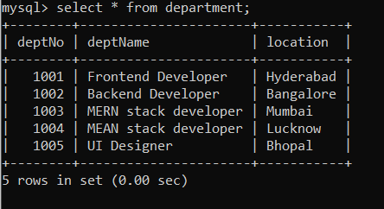

**2**. Display the details of all employee **Query:**

select * from employee;

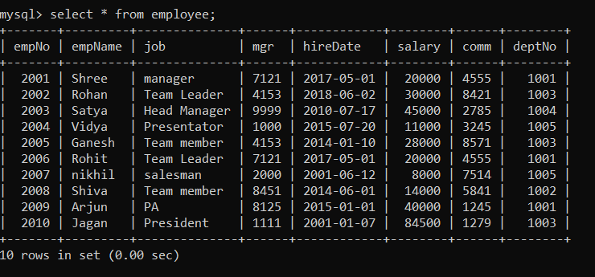

**3.** display the name and job for all employee

**Query:**

select empName,job from employee;

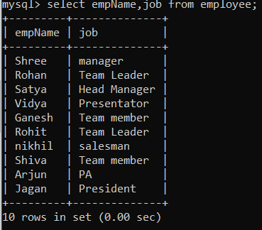

**4.** display name and salary for all employee

**Query:**

select empName,salary from employee;

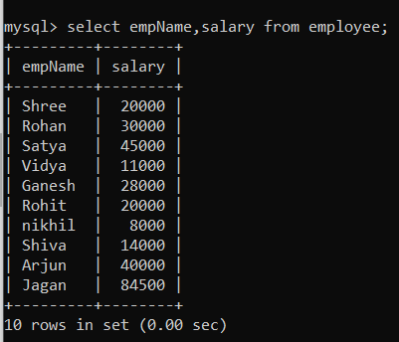

**5.** display employee number and total salary for each employee

**Query:**

select empNo,salary +comm as “total salary” from employee;

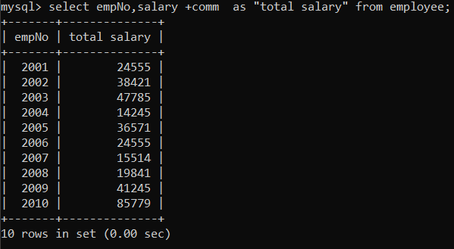

**6.** display employee name and anual salary for all employee

**Query:**

select empName,12*(salary) as “annual salary” from employee;

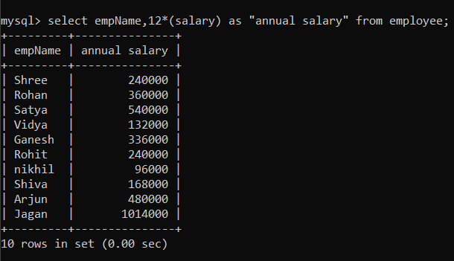

**7.** display the names of all employee who are working in department number 1001

**Query:**

select empName from employee where deptNo =1001;

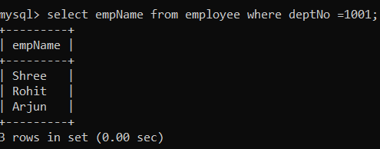

**8.** display the names of all employee working as salesman and drawing a salary more than 3000 **Query:**

select empName from employee where job=”salesman” and salary > 3000;

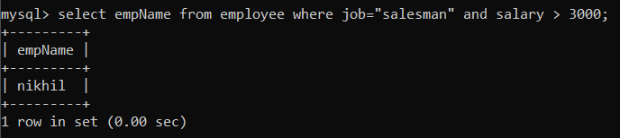

**9.** display employee number and names for employee who earns commission

**Query:**

select empNo,empName where comm>0;

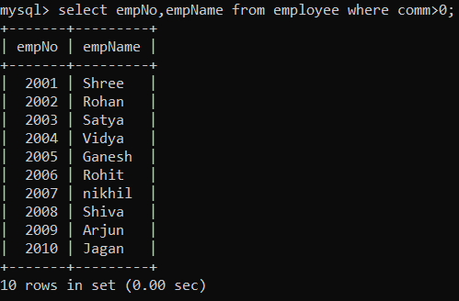

**10.** display names of employee who do not earn any commission **Query:**

select empName from employee where comm =0;

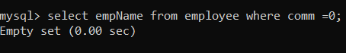

**11.** display the names of employee who are working as manager, salseman or Ream leader and drawimg a salary more than 10000 **Query:**

select empName from employee where job="manager" or job = "salesman" or job="Team Leader" and salary > 10000;

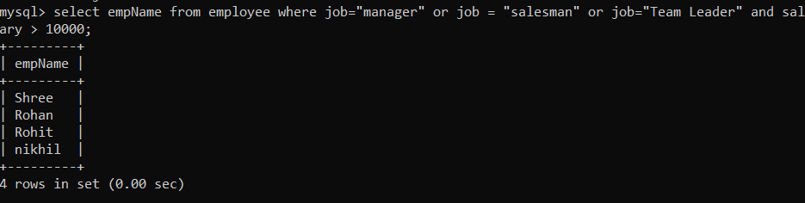

**1 2.** display the names of employee who are working in company for the past 5 years

**Query:**

select empName from employee where hireDate >=”2015-01-01”;

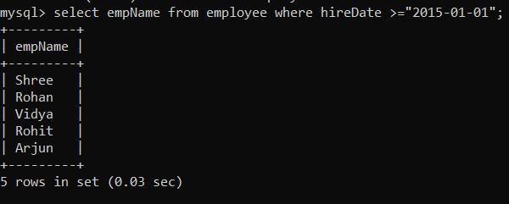

**13.** display the list of employee who have joines the company before 30 june 90 or after 31dec 90 **Query:**

select empName from employee where hireDate <=”1990-06-30” or hireDate >= “1990-12-31”;

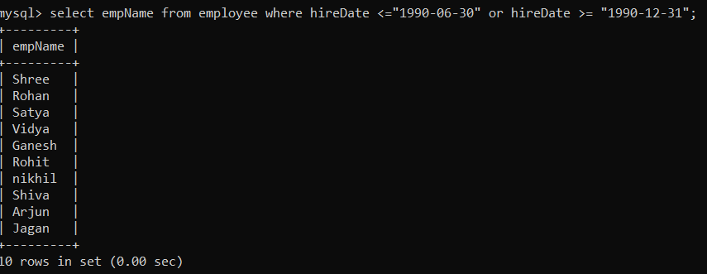

**14.** display the names of employee working in department number 1001 or 1003 0r 1005 or employee working as clerks, salseman or analyst.

**Query:**

Select empName from employee where deptNo = 1001 or deptNo = 1003 or deptNo=1005;

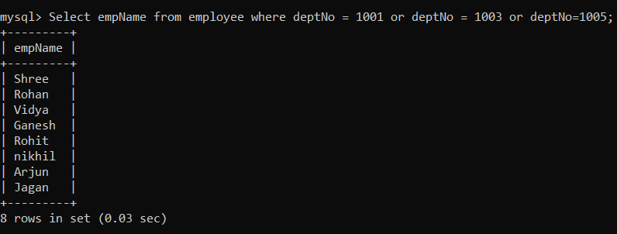

**15.** display names of employee whose name starts with alphabet S.

**Query:**

select empName from employee where empName like “S%”;

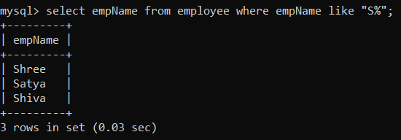

**16.** display names of employee whose name ends with alphabet S

**Query:**

select empName from employee where empName like “%S”

;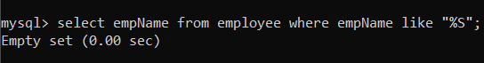

**17.** display the names of employee whose names have second alphabet A in their names

**Query:**

select empName from employee where empName like “_a%”;

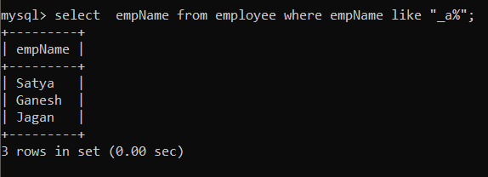

**18.** display the names of employee whose name is exactly five charactere in length **Query:**

select empName from employee where length(empName)=5;

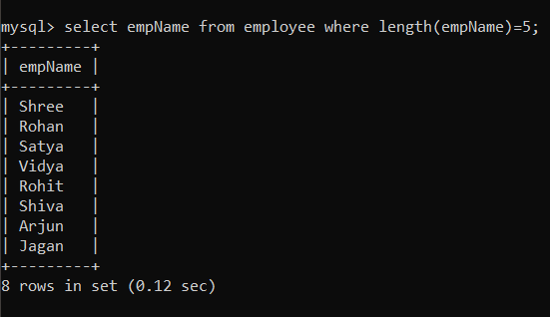

**19.** display the total number of employee working in the company

**Query:**

Select count(empNo) from employee;

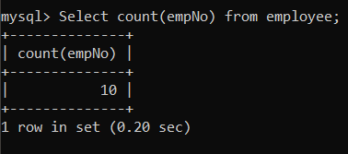

**20.** display the total salary being paid to all employee

**Query:**

select sum(salary) from employee;

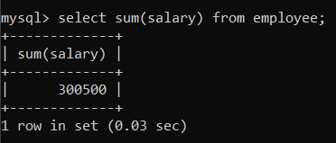

**21**. display the maximum salary from emp table

**Query:**

select max(salary) from employee;

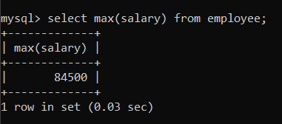

**22.** display minimum salary from emp table **Query:**

select min(salary) from employee;

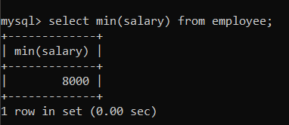

**23.** display the average salary from emp table **Query:**

select avg(salary) from employee;

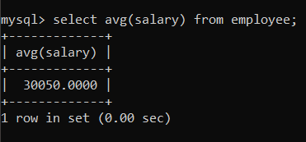

**24.** display the maximum salary being paid to salesman

**Query:**

select max(salary) from employee where job=”salesman”;

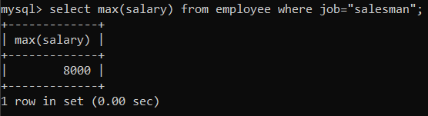

**25.** display the maximum salary being paid in dept no 1002

**Query:**

select max(salary) from employee where deptNo=1002;

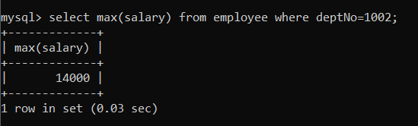

**26**. display the min salary being paid to any salseman **Query:**

select min(salary) from employee where job=”salesman”;

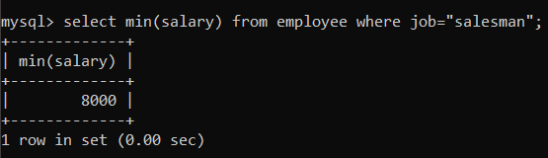

**27.** display the average salary drawn by manager **Query:**

select avg(salary) from employee where job=”manager”;

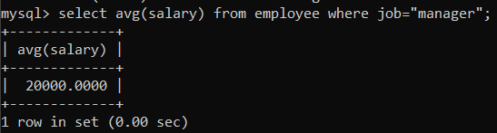

**28.** display the names of employee in order of salary i.e the name of the employee earning lowest salary should appear first **Query:**

select empName from employee order by salary;

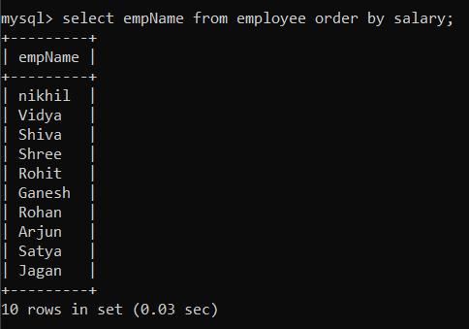

**29.** display the names of employees in descending order of salary **Query:**

select empName from employee order by salary desc;

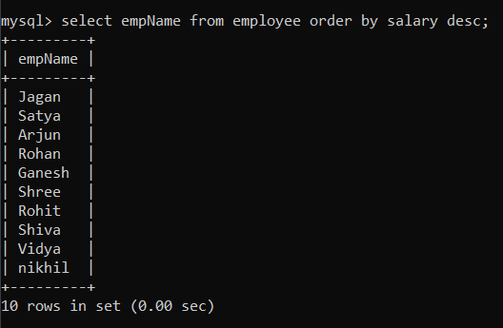

**30.** display the details from emp table in order of emp name

**Query:**

select empName from employee order by empName;

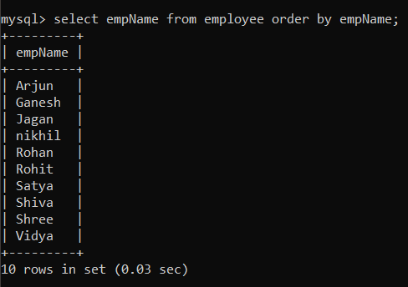

**31.** display empno ename deptno and sal. sort the output first based on name and within name by deptno and within deptno by sal .

**Query:**

select empNo,empName,deptNo,salary from employee order by empName,deptNo,salary;

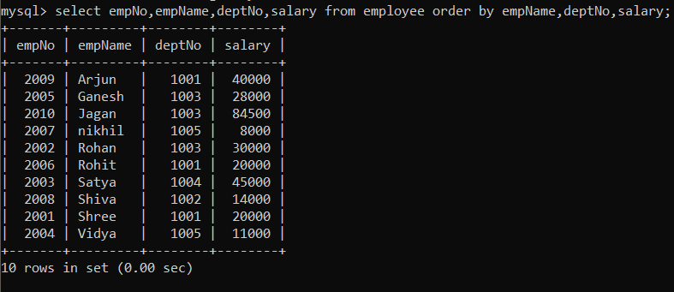

**32.** display the name of the employee along with their annual salary (sal*12) the name of the employee earning highest annual salary should appear first.

**Query:**

select empName,12*(salary) as “annual salary” from employee order by 12*(salary) desc;

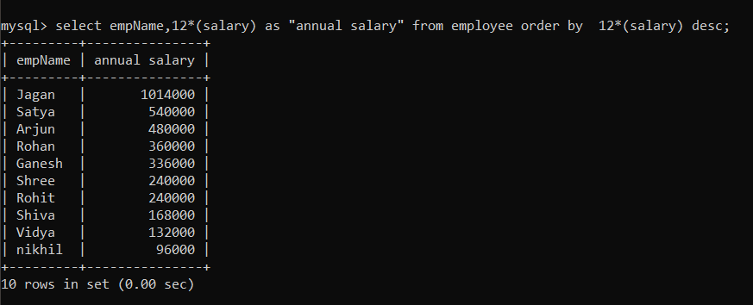

**33.** display name, sal, hra, pf, da, total sal for each employee. the output shouldbe in the order oftotal sal, hra 15% of sal,da 10% of sal, pf 5%of sal total salary will be (sal*hra*da)-pf

**Query:**

select empName,(0.15*salary) as “hra”,(0.1*salary) as “da”,(0.05*salary) as “pf” , ((salary*0.15*salary*0.1*salary)-(0.05*salary)) as “total salary” from employee;

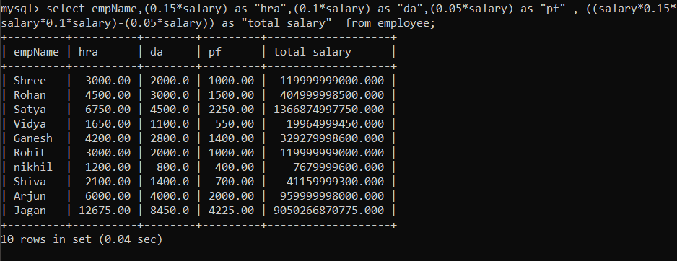

**34.** display dept number and total number of employees within each group

**Query:**

select deptNo,count(empNo) as “totalEmp” from employee group by deptNo;

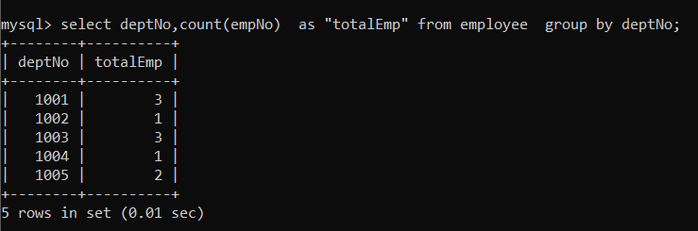

**35.** display the various jobs and total number of employee with each job group **Query:**

select job,count(empNo) from employee group by job;

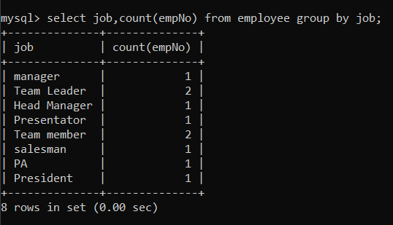

**36.** display department number and total salary for each department

**Query:**

select deptNo,sum(salary) as “total salary” from employee group by deptNo;

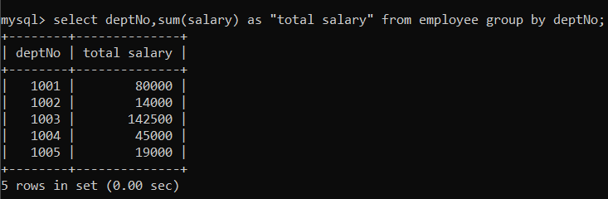

**37.** display department number and maximum salary for each depatrment **Query:**

select deptNo, max(salary) from employee group by deptNo;

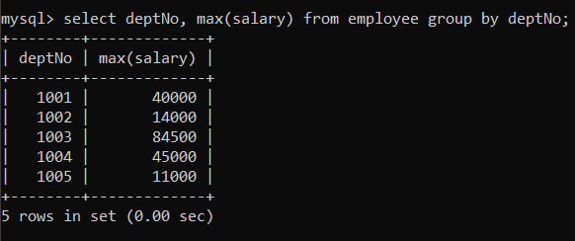

**38.** display the various jobs and total salary for each job **Query:**

select job ,sum(salary) as “total salary” from employee group by job;

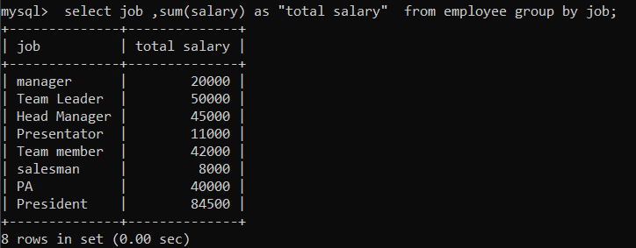

**39**. display each job along with minimum sal being paid in each job group

**Query:**

select job,min(salary) from employee group by job;

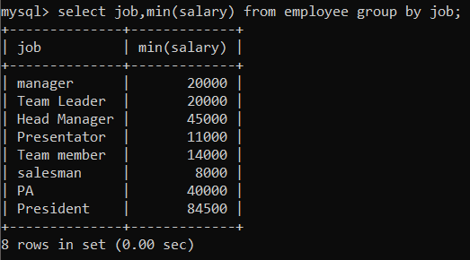

**40.** display the department numbers with more than three employee in each dept

**Query:**

select deptNo ,count(deptNo) from employee group by deptNo having count(*)>3;



**41.** display the various jobs along with total sal for each of the jobswhere total sal is greater Than 40000.

**Query:**

select job,sum(salary) as “total salary” from employee having sum(salary) > 40000;

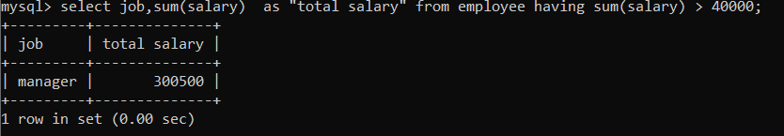

**41.** display the various jobs along with total number of employee in each job. the output should contain only those jobs with more than three employee

**Query:**

select job,count(empNo) from employee group by job having count(empNo) > 3;



**43**. display the name of emp who earns highest sal **Query:**

select empName from employee where (salary= (select max(salary) from employee));

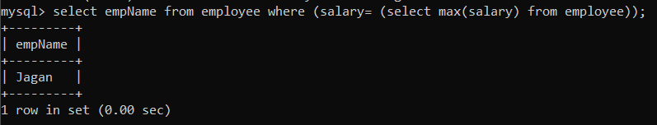

**44**. display the employee number and name of employee working as salesman and earning highest salary among salesman.

**Query:**

Select empNo,empName from employee where job=”salesman” and salary=(select max(salary) from employee where job=”salesman”);

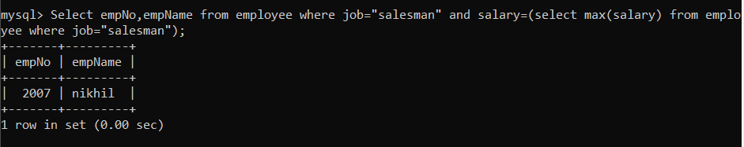

**45.** display the names of salesman who earn salary more than that of james of that of sal lesser than that of scott.

**Query:**

select empName from employee where job=”salesman” and salary>(select salary from employee where job=”salesman” and empNo=20011) and salary <(select salary from employee where job=”salesman” and empNo=20012);

